Unit: ____________________Topic: _______________________ Course: ______ Date: __/__/____

Standards: ____________________ Source: ____________________________________________

 | Statement(s) |  | Question(s)
Setting up the Problem | Ask a student to read the problem.  Possibly this video…..it makes me laugh  http://www.youtube.com/watch?v=oivWKzaVOO4
 | Anticipated Strategies/Misconceptions | Who | Questions
Monitoring Student Work | TABLE: |  | -What is the meaning of the x?  -What patterns are you noticing in your table?  -What type of function is plan A, plan B?  -Do we see where one plan is better than the other in the table? If so, where?  - What does the f(x) represent in the table? What do the negative values mean?
 | GRAPH:  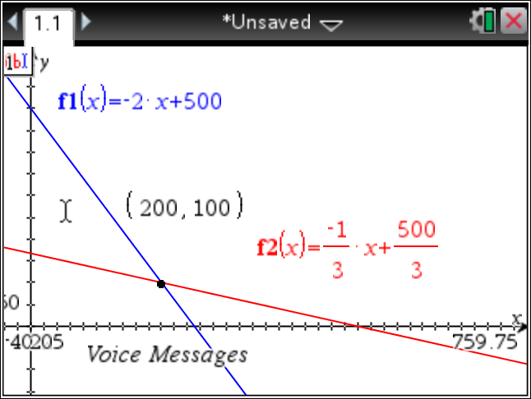 |  | -What does the point of intersection tell us?  -Why is happening before the intersection point, after the intersection point?  -What does the x represent?  What does the f(x) represent?
 | EQUATION: x= voice minutes  y = text messages  Plan A: .05x + 15y = 25  y = -1/3x + 500/3  f(x) = -1/3x + 500/3  Plan B: .10x + .05y = 25  y = -2x + 500  f(x) = -2x + 500 |  | -What do the coefficients represent?  -Does it matter which variable is the input (x) and which is the output(y)?
 | Guess and Check:  Voice ONLY  Plan A: 500 minutes  PlanB: 250 minutes  Text ONLY  Plan A: 166 messages  Plan B: 500 message |  | -What are the benefits of each plan?  -What happens when a person only talks on the phone?  -What happens when a person only text messages?
 | Misconceptions |  | -making one equation with all information  - turning the problem into a systems only and finding just the point of intersection
 | Non starters |  | -What do you know about the problem?  -What question are we trying to answer?  -Can you draw a picture?  -Might a table help you get started? What are our variables?
 | Parts of Discussion | Questions/Statements
Managing the Discussion | Launching the Discussion | What was unclear about the problem?  What did you do first when working on the problem?
 | Eliciting Student Strategies | Joe, would you be willing to start us off?  Can you repeat that?  Can you explain how you got your answer?  Walk us through your steps.
 | Focusing on Mathematical Ideas | Can you explain why your equation matches the data?  How is Joe’s method similar to Sue’s method?  How is Sue’s equation similar to Tom’s? Are they equivalent? How can we tell?
 | Encouraging Interactions | What do others think?  Do you agree or disagree with Amy’s strategy?  Would someone be willing to repeat what Tom just said?  Allison, will you add to what Tom just said?
 | Concluding the Discussion | Tomorrow we will continue our exploration of linear patterns beginning with the tiling pattern from today.
Post Lesson Notes

