Session 1
[Note: Session 1 of the performance task consists of two Parts: A and B. Part A should be performed individually. Part B should be performed in pairs or small groups. The teacher should allow for the majority of Session 1 to be devoted to group work.]
To do this, teachers will compile the complete list of schools provided by the students. They will enter each school into the search tool provided below.
http://chronicle.com/article/Interactive-Tool-Tuition-Over/125043/
Screen shots will be made of each school’s tuition data. The screen shots will then be combined to form the simulated search tool to be used by the students when they begin Session 1 of the task.
College Tuition Your Assignment: Based on your research during the last few days, you may have realized that the cost of a college education in the United States can be expensive. During this performance task, you will use a spreadsheet and your knowledge of functions and statistics to predict the future cost of college tuition.
Steps you will be following:
To accomplish this, you will use a spreadsheet to help perform the following:
- Gather data on the past year’s tuition amounts.
- Analyze the data and choose a model type that will best predict the future tuition total.
- Develop a model equation based on the model type chosen.
- Predict the total tuition amount for a 2-year or a 4-year college education in the near future.
- Compare the predicted total tuition amount using the model equation with the total predicted tuition amount you calculated prior to the start of this task.
- Compare tuition amounts at the college you chose with the average tuition amounts of all public 4-year colleges in the United States.
- Predict the total tuition amount at a 2-year or a 4-year college education in the distant future.

Part A
Past Year’s Tuition
During the past few days, each of you chose a specific college or university to research. In order to predict the total tuition amount at that college or university, you must first research past year’s tuition amounts for that school.
http://chronicle.com/article/Interactive-Tool-Tuition-Over/125043/

You will use a computer to search for these data specific to the school you chose. Your search will provide you with the combined cost for tuition and school-related fees at your school over the past several years. Gather these data and enter them into a spreadsheet. The data must include the tuition and school-related fees, as one total dollar amount, for the past 10 years.
[Note: With the data provided on the simulated searches in this example, that will be for the years 2001-2010.]

Part B Choosing a Model
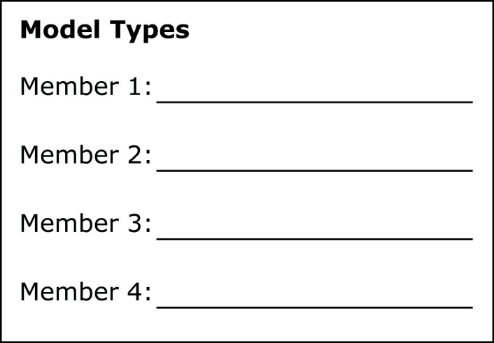
After you have collected your data and entered it into the spreadsheet, get into pairs or groups of 3 or 4. In your group, you will analyze each team member’s data by determining the following:
- what the data looks like graphically
- what outliers, if any, exist
- what model type, either linear or nonlinear, best fits the data

As a group, decide which model type will be used to determine the function (model equation) that will predict each member’s future tuition amounts at his/her chosen school. The model types may or may not be the same for all group members.

Look for similarities and differences in each group member’s data. Discuss some reasons why the data cause the model types for each group member to be the same or different.

[Note: Allow 5-10 minutes at the end of Session 1 for a whole class discussion about what was discovered during the group work. Students should discuss the reasons they came up with for why the model types in their individual groups, and the class as a whole, may or may not be the same.]

End of Session 1

