Week #8: R U Ready for the MME? Geometry/Algebra 1 Practice Name ________________________

Date ________________ Hr ____

Geo: 3-3 Alg: 7-1

Find the value of each variable.



1. n = ___________ 2) x = _______ y = _______ z = _______
2. Find the value of the numbered angle.

3) m ∠ 2 = _______

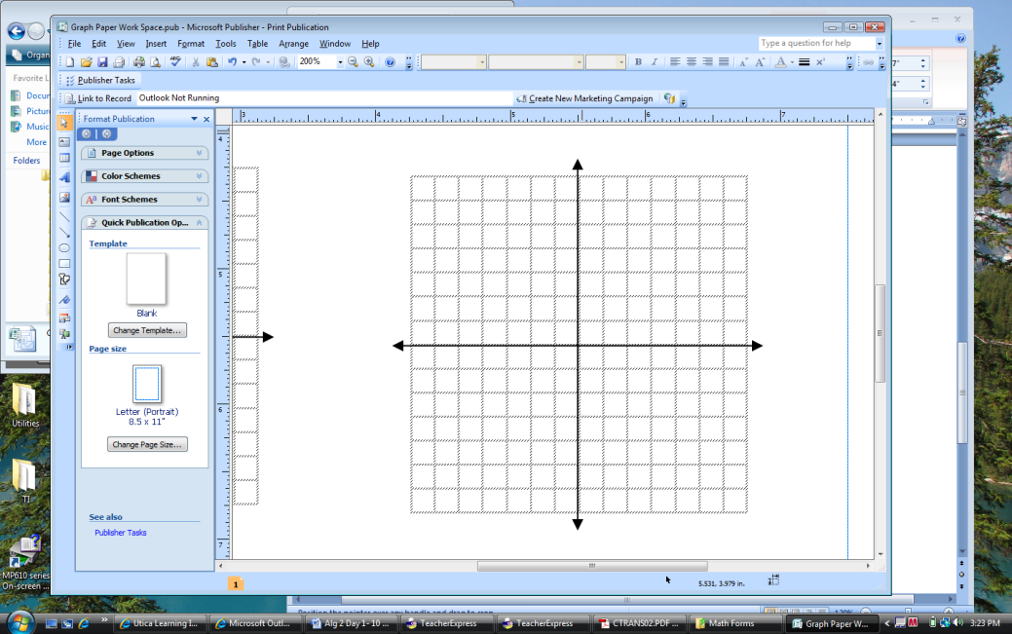

4) Solve by graphing.

4) Answer ___________________

5) Solve using a graphing calculator. Write no solution or infinitely many solutions where appropriate.

5) Answer __________________