Week #5: R U Ready for the MME? Geometry/Algebra 1 Practice Name ________________________

Date _________________ Hr _____

Geo: 2-2 Alg: 6-3

Each conditional statement is true. Consider each converse. If the converse is **true**, combine the statements and write them as a **biconditional.** If the converse is **false**, explain **why**.

1. If two angles have the same measure, then they are congruent.

____________________________________________________________________________

1. 

____________________________________________________________________________

1. Explain why the following is not a acceptable definition:

An automobile is a motorized vehicle with four wheels.

____________________________________________________________________________

1. Write this equation in standard form using integers. 

4) Answer ___________________

1. The student council is sponsoring a carnival to raise money. Tickets cost $5 for adults and $3 for students. The student council wants to make $450.
   1. Write an equation to find the number of each type of ticket they should sell.

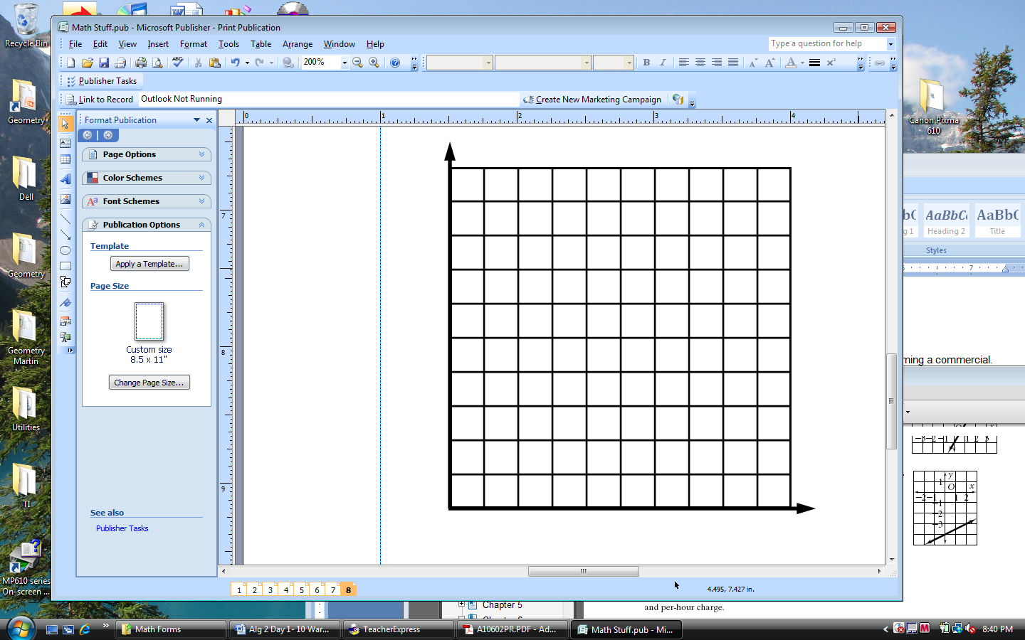__________________________________

* 1. Graph your equation.
  2. Use your graph to find two different combinations of tickets sold.

___________________________________ __________________________________