Week #4: R U Ready for the MME? Geometry/Algebra 1 Practice Name ________________________

Date _________________ Hr ____

Geo: 2-1 Alg: 5-5, 6-1

1. Write the converse of this conditional: “If you drink milk, then you will be strong.”

_______________________________________________________

Write the converse of each statement. If the converse is true, write true; if it is not true provide a counterexample.

1. If  is positive, then *m* is positive.

Converse: ____________________________________________________________

True or Counterexample: ___________________

1. If two lines have equal slopes, then the lines are parallel.

Converse: ____________________________________________________________

True or Counterexample: ___________________

1. Find the slope that passes through 

4) Answer _________________

1. A television company charges a basic fee of $4000 and then $2000 per hour when filming a commercial.
   1. Write an equation in slope-intercept form relating the basic fee and the per-hour charge.

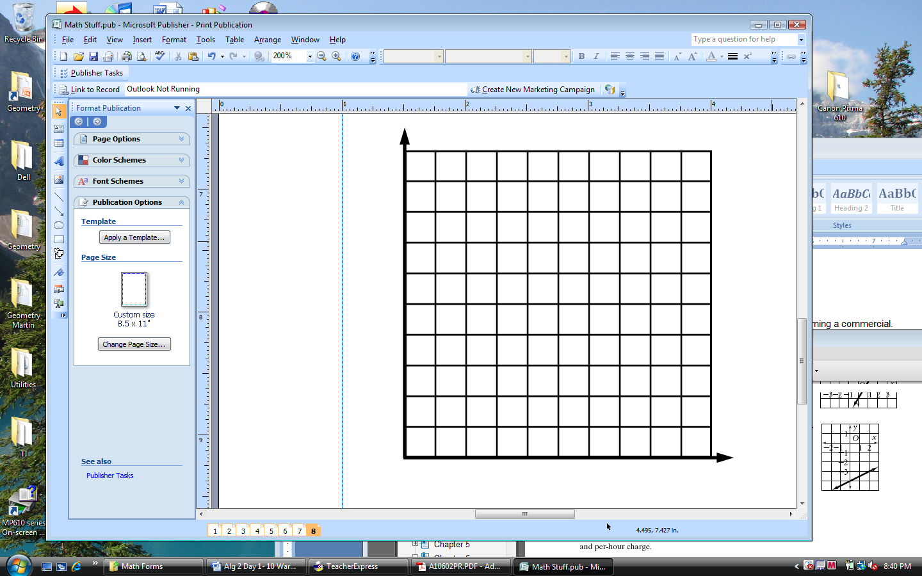_______________________________________________

* 1. Graph the equation.
  2. Use the graph to find the production costs if 6 hours of filming were needed.

5) Answer _________________