Week #19: R U Ready for the MME? Geometry/Algebra 1 Practice Name ________________________

Date __________________ Hr ____

Geo: 6-2 Alg: 8-7

Find the measures of the numbered angles for each parallelogram.



1. m∠1 = _____ m∠2 = _____ 2) m∠1 = _____ m∠2 = _____

m∠3 = _____ m∠4 = _____ m∠3 = _____

1. Find the length of  in this parallelogram. *TR* = 14, *ME* = 31

3)  = _______

4) Graph: 5) Evaluate the function for the domain 



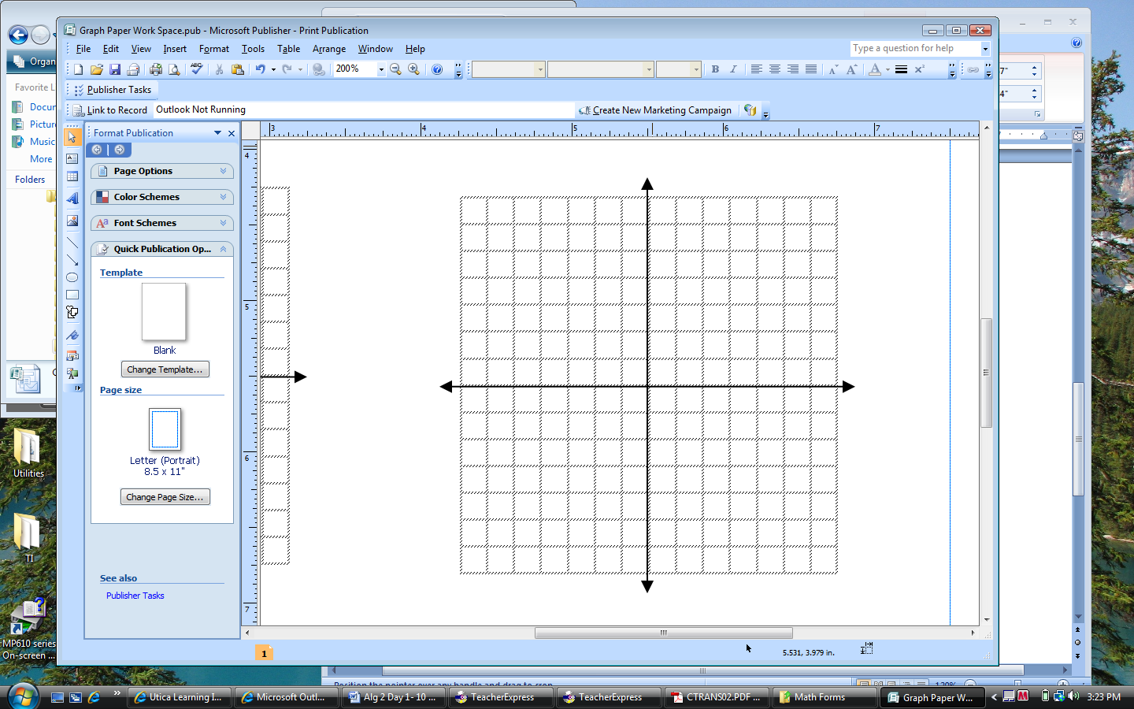

5) Answer _______________________________