Week #1: R U Ready for the MME? Geometry/Algebra 1 Practice Name ________________________

Date __________________ Hr ____

Geo: 1-5 Alg: 5-2, 3

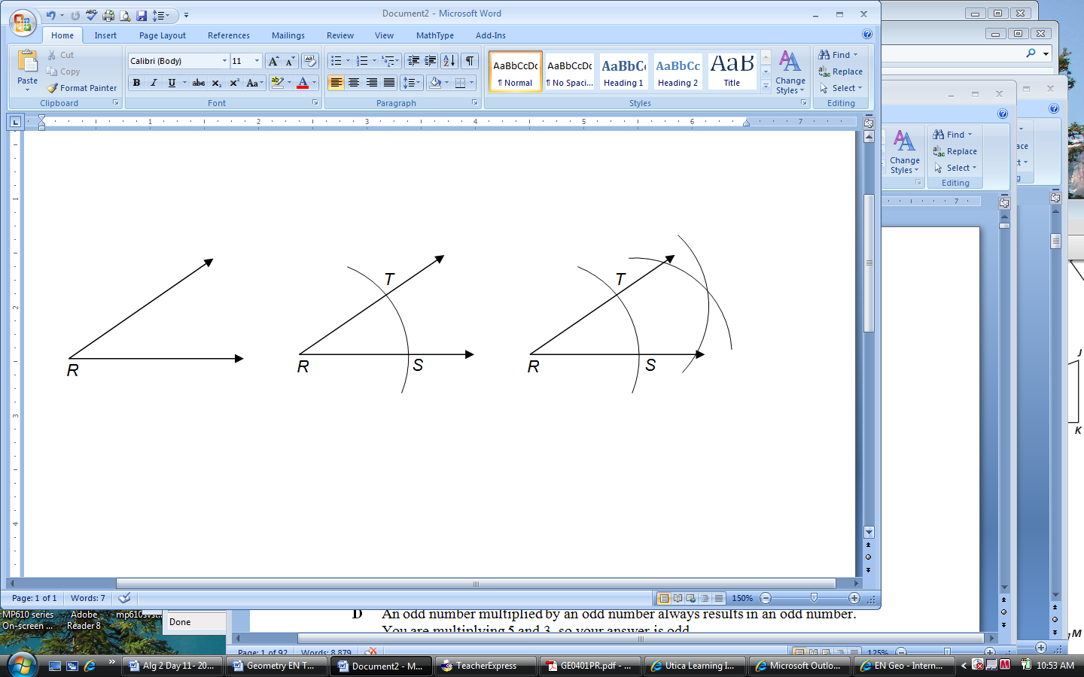

1. What is the construction that is being performed:
   1. Perpendicular Bisector
   2. Angle Bisector
   3. Construction of an isosceles triangle
   4. Construction of a right triangle 1) Answer _______
2. True or False? The perpendicular bisector of a line segment creates four 90° angles. ___________



1. Find the range of this function, given the

Range: __________________

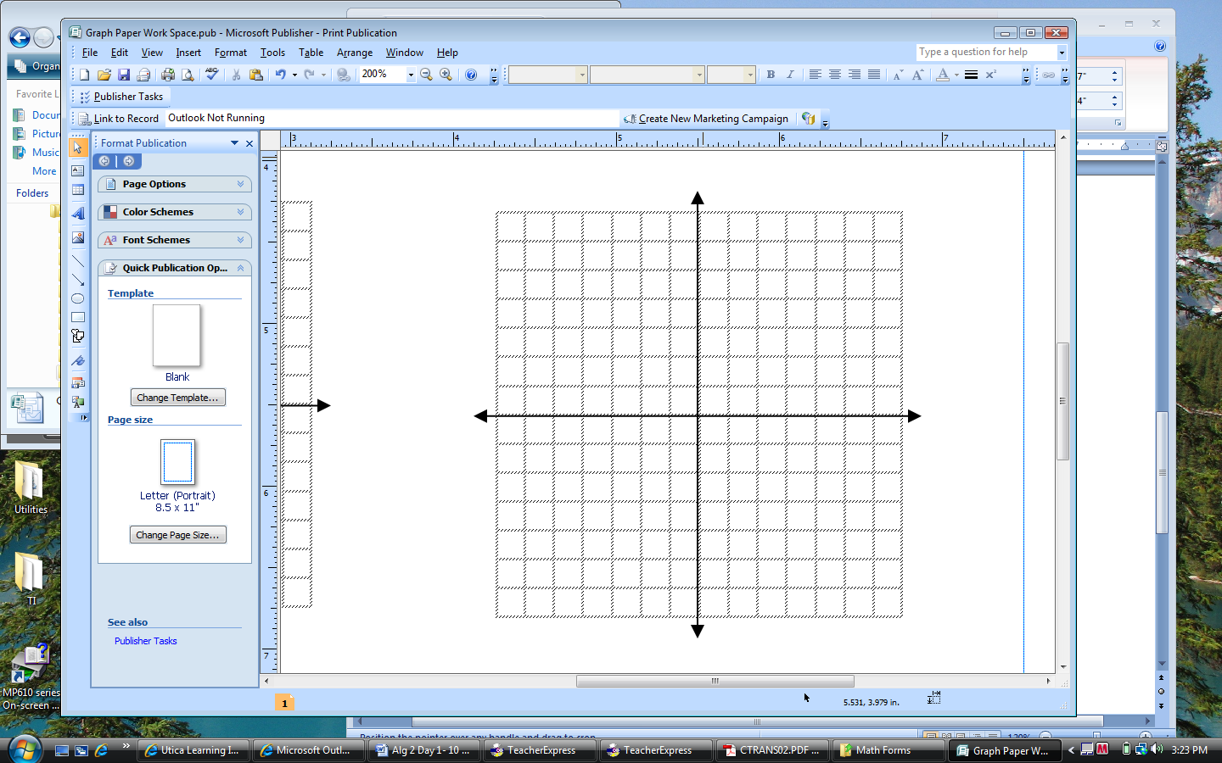

1. Graph: 
2. Graph: 