UCS Algebra II Semester 1 REVIEW GUIDE 2 Name ______________

1 | Mark keeps track of the number of customers he serves each hour at the coffee shop. His results are shown in the table below. Make a histogram that models this data.  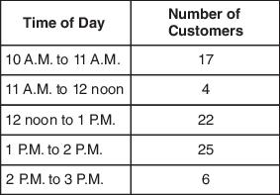

2 | Karisa counted the number of raisins in twenty snack size boxes and found that the number of raisins in each box was normally distributed with a mean of 112 raisins and standard deviation of 8 raisins. What is the probability that a box contains between 104 and 112 raisins?

3 | Tucker needs to find out the number of defective light bulbs on a truck. He noted that 4 out of 46 light bulbs were defective from a randomly selected box. Based on these results, about how many light bulbs can he expect to be defective in a truckload of 12,500 light bulbs?

4 | A music teacher wants to conduct a survey to determine how many students plan to attend a school concert. How should she collect a good random sample to give the MOST accurate survey results? Explain your answer.

5 | A sample survey of 2,450 voters revealed that 53% planned to vote for candidate A in an upcoming election. The poll had a $±$3% margin of error. If there are 205,000 total voters, what is the likely range of voters intending to vote for candidate A?

6 | A survey was conducted at Keller Middle School to determine the favorite subject of students. The results of the survey are shown in the graph below.  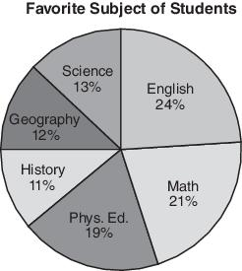  The total number of students surveyed was 300. How many more students picked English over Math?

7 | What is the coefficient of n²?  (n² – 3) – (7 – n + 3n²) – (4n + 1 – 8n²)

8 | Kristen is 2 times as old as her younger brother, Luke. Which equation represents their ages, in years, if Kristen’s age is k and Luke’s age is l?

9 | Sketch the graph of each of the parent functions listed below:

10 | A club is selling hats and jackets as a fundraiser. Their budget is $1500 and they want to order at least 250 items. They must buy at least as many hats as they buy jackets. Each hat costs $5 and each jacket costs $8. Let h = number of hats and j = number of jackets.  - Write a system of inequalities to represent the situation.  - Graph the inequalities.  - If the club buys 150 hats and 100 jackets, will the conditions be satisfied?

11 | Jamie is building a rectangular dog pen in her backyard with 80 feet of fencing. The pen’s area is given by $A\left(x\right)=x(40-x)$ , where $x$ is the length of fencing measured in feet along one side of the pen. Which inequality represents the domain of this function given the context it represents?

12 | Determine the quadratic equation that has zeros that $x=-2 and x=5.$

13 | Use a polynomial identity to show an equivalent expression for ${(u+v)}^{2}$ .

14 | Heather graphed the following equations.  Equation 1: $y=\frac{4}{3}x-2$  Equation 2: $12x-9y=27$  Equation 3: $2x+4y=-8$  - How do the graphs of equations 1 and 2 compare? What is their point of intersection?  - How do the graphs of equations 1 and 3 compare? What is their point of intersection?  Use words, numbers, and/or pictures to show your work.

15 | Factor the following expression.  $$12x^{2}-60x+75$$

16 | Determine the end behavior of the equation below. Explain how you made your decision.  $f(x)={-3x}^{7}+{4x}^{5}-12x^{3}+{9x}^{2}-16$  As $x→-∞, f\left(x\right)→________$  As $x→+∞, f\left(x\right)→_______$

17 | What is the domain of the function graphed below?  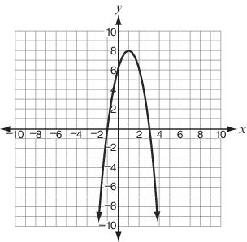

18 | What are the domain and range of $(x)=\frac{4x+1}{x-2}$ ?

19 | Write the expression $5(x-1)(x-3)$ in standard form. What is the coefficient of $x$?

20 | Below is the graph of a cubic polynomial.  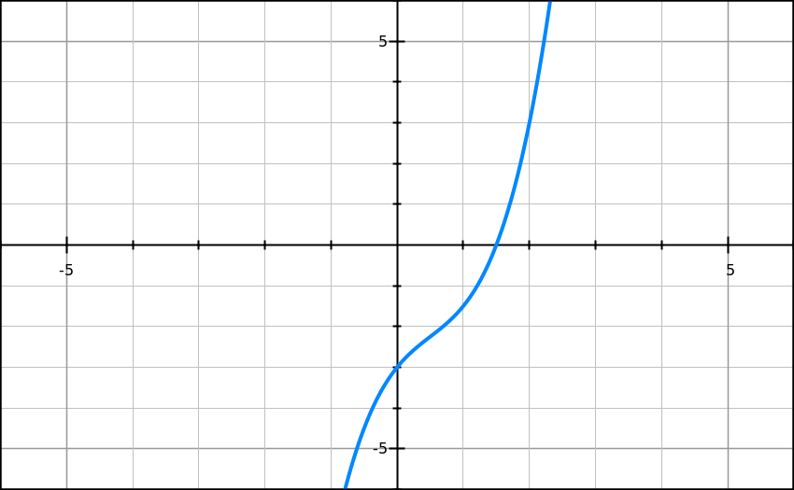  What is the average rate of change between x-values of 0 and 2?

21 | Let $f\left(x\right)=\frac{x+1}{x^{2}-5x-14}$  What are all the vertical asymptotes of the graph of $f\left(x\right)$ ?

22 | Given: $P\left(x\right)=x^{5}+{4x}^{3}-5x$  - Find all the zeros of $\left(x\right)$ .  - How many real zeros does $P\left(x\right)$ have, and what are they?  - How many total zeros over the complex numbers does $P\left(x\right)$ have, and what are they?

23 | What is the sum of and ?

24 | Which solutions satisfy the equation ?

25 | Write 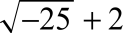 as a complex number in the form .

26 | Which polynomial can be factored over the complex numbers as ?

27 | A polynomial function has zeros at: $2, -4 and 5i$.  - How many total zeros over the complex numbers does the function have, and what are they?  - Write an equation that represents this function.  - What is the degree of this function?  Use words, numbers, and/or pictures to show your work. Write your answer(s) on the paper provided

28 | Two functions are defined as $f\left(x\right)=3x^{4}+2x^{3}-7x^{2}-3$ and $g\left(x\right)=x-2$ .  - Use synthetic division to determine if $g(x)$ is a factor of $f(x)$.  - Find $f(2)$.  - What can be concluded about the relationship of these functions?

29 | Find the zeros of the function $f\left(x\right)=2x^{2}+x-3$  - Write $f\left(x\right)$ in factored form.  - Find the roots.  - Find the maximum or minimum value.  - State the axis of symmetry.

30 | Four downhill skiers recently performed multiple trials on the same run. The table below shows the mean times and standard deviations of each skier.  Mean Times for Skiers  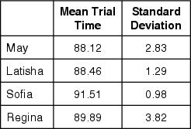  A ski coach has to choose one of the skiers to compete in a tournament. The coach wants to choose the skier who most consistently gets a time below 90 seconds. Based on the information in the table, which skier is the BEST choice?
31 | Determine the end behavior of the equation below using limit notation. Explain how you made your decision.  $y={3x}^{8}+{4x}^{5}-12x^{3}+{9x}^{2}-16$

32 | Use the function; f(x) = x(x + 3)(x – 1)² to answer the following questions.  a). Identify the zero(s).  b). Identify the y – intercept.  c). Graph the function.  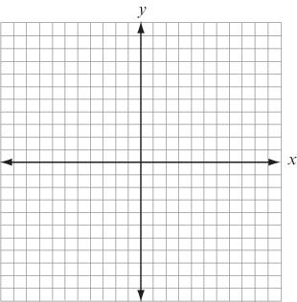

33 | Connie is working with the graph of $f\left(x\right)=x^{2}-4.$  - Graph $f\left(x\right)=x^{2}-4.$  - Find a function, g(x), that opens in the same direction as f(x) but that represents a narrower parabola. Explain your work.  - Graph g(x).  Use words, numbers, and/or pictures to show your work.

34 | The graph of $f\left(x\right)=\frac{1}{x}$ is shown below.  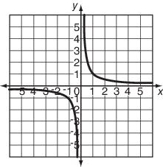  - Graph $g\left(x\right)=-\frac{3}{x-2}-1$ on the same graph.  - Write the equations of the asymptotes for $g\left(x\right).$  - What is the domain and range of $g\left(x\right)?$

35 | The following test scores were recorded for two Algebra II classes.  1st hour: 43, 56, 77, 43, 49, 51  4th hour: 34, 88, 78, 76, 54, 89  Compare the means, medians, and modes.

36 | 2000 students were surveyed and showed that 72% of students owned a car with a margin of error of ±4%. What is the percent interval of students who own a car?

37 | John’s grade is twice as high as Stacy’s. If j is John’s grade and s is Stacy’s write two equations to model this situation.

38 | On a boating trip in Minnesota the temperature was 76º at 8:00 am. By 2:00 pm the temperature had risen to 88º. What was the average rate of change in degrees per hour?

39 | Find the roots to the equation: $2x^{2}+26x+72=0$  Name two other terms we use for roots.

40 | - Find the difference. $\left(2+7i\right)-\left(-6-10i\right)$  - Find the sum $\left(2+7i\right)+\left(-6-10i\right)$  - Find the product $\left(2+7i\right)∙\left(-6-10i\right)$

41 | - Factor $27x^{3}-125$  - Factor $64x^{3}+8$  - Factor $16x^{2}-24xy+9y^{2}$  - Factor $3x^{3}+12x^{2}+15x$

42 | If $y=2x^{2}-5$ and the domain is all negative real numbers, what is the range of the function?

43 | - Write the equation of the graph that translates $y=\frac{1}{x}$ 3 units left, 2 units up, and is reflected over the $x-$ axis.  - Graph and describe the translation of $y={(x-4)}^{3}+3$.

44 | Identify all points of discontinuity for $f\left(x\right)=\frac{x(x-1)(x+2)}{(x+2)(x-3)\left(x-7\right)}$ and classify those points as vertical asymptotes or holes in the graph.

45 | The following Box and Whisker plots show Carl’s and Angela’s sales for the month.  - Who had higher median sales?  - Who had a smaller Inter Quartile Range?  - Compare the ranges.  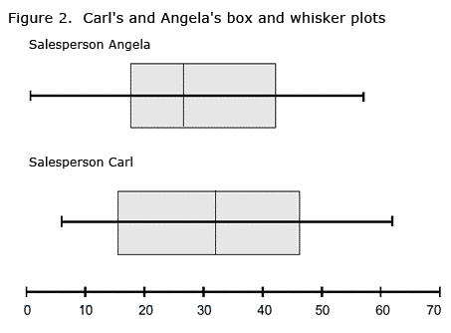  - Whose standard deviation will be higher?

46 | Given the following Normal Distribution curve, answer the following:  - What percentage of the data lies within 2 standard deviations of the mean?  - If there were 800 people in this data set, how many people are between 2 standard deviations above the mean and 1 standard deviation below the mean?  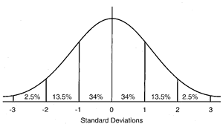

47 | A survey of 1548 students was conducted to determine what their favorite ice cream was.  467 prefer vanilla  393 prefer strawberry  512 prefer chocolate  176 prefer other flavors  What is the sample proportion for those who prefer chocolate?

48 | This graph shows the Revenue and Expenses for a company from 1994 to 2003.  - The expenses in 1996 are twice as much as the revenue.  TRUE or FALSE. Explain.  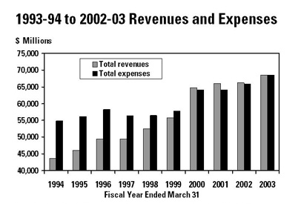  - The difference in revenues between 1999 and 2000 is about 10 billion.  TRUE or FALSE. Explain.

49 | The following scatterplot shows the number of beach visitors compared to the average daily temperature.  - The data shows a positive trend.  TRUE or FALSE. Explain.  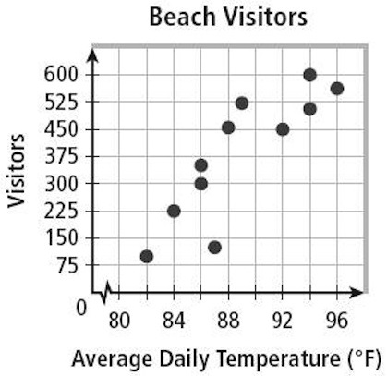  - The data shows that as temperature rises there are ALWAYS more visitors.  TRUE or FALSE. Explain.

50 | Use the polynomial graph for the following.  - Find the zeros of the given polynomial graph and identify any multiplicity associated with those zeros.  - List the intervals where the function is increasing.  - List the intervals where the function is decreasing.  - The graph has ________ relative maximums.  - The graph has ________ relative minimums.  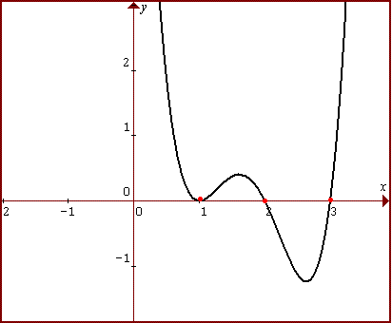

51 | The last math test had 28 questions consisting of TRUE and FALSE questions (2 points each) and SHORT ANSWER questions (3 points each). If the test was worth 64 points, how many of each type of question is there?  - Write a set of equations that models this situation.  - Solve the system of equations using elimination or substitution.

